TITLE:- LED CHASER LIGHT

# AIM:-To make LED chaser light using arduino board.

## Hardware Required:-Arduino board,led lights,resistors,bread board and

## Jumping wires.

## Circuit Diagram:-

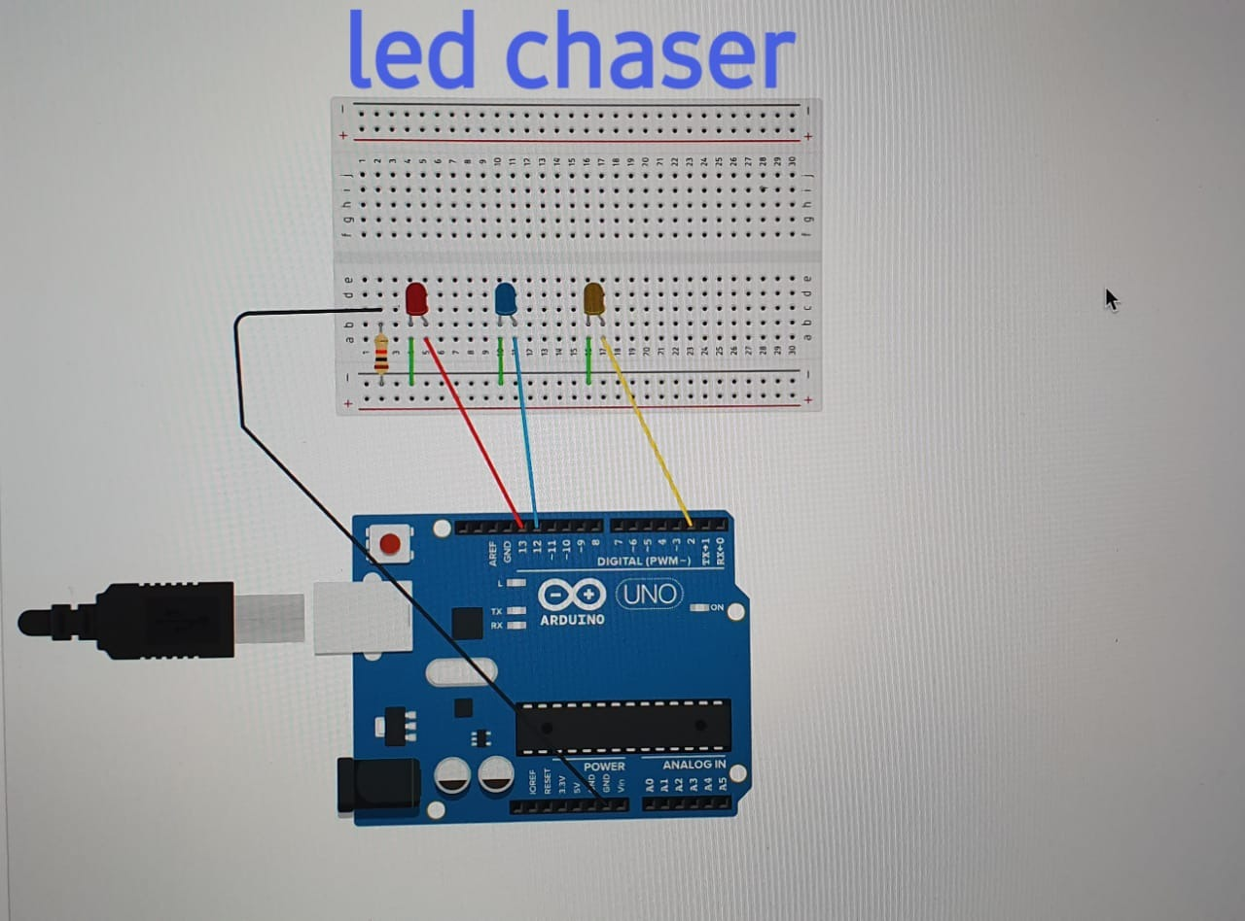

## THEORY

# This in the circuit of a simple LED chaser.The LEDs lights one by one for a period of 1 second and the cycle repeats giving the running light appearance.The circuit consist of LEDs,arduino,bread board,resistor and jumping wires.

# Breadboard is a construction base for prototyping of electronics.It is solderless and does not require soldering,it is reusable.A modern solderless breadboard consist of block of plastic with numerous tin plated phosphor broze or nickel silver alloy.

# Arduino is a open source electronics platform based on hardware and software . Arduino boards are able to read inputs – light on a sensor,a finger on a button and turn it into output-activating motor and turning on LEDs.

# CONCEPT

# Take 10 resistor of each 200 ohm and LEDs of different colours connect the cathode end of all LEDs to the GND pin of all LEDs with each resistor connected to the end .Now connect the resistor end to pin 2,11,12,13 to arduino .Do connection same as circuit diagram . Patters of LEDs can be made by improving the code.

# OBSERVATION

# When arduino board gets connected with PC,the information in the form of voltage, current will gets transferred to arduino board, the LEDs will start glowing and we will observe a chaser pattern.

# PROBLEM AND TROUBLESHOOTING

# Arduino might be connect with wrong serial port which ultimately fails to glow the LEDs.

# The arduino may be connected with wrong USB port

# The resistor used may be of high value which causes LEDs not to glow

# PRECAUTION

# 1.Make sure to connect arduino uno with right serial port.

# 2.Check the connection carefully in breadboard before executing the code

# 3.Do not use resistor of high resistance

# 4.Make sure that arduino uno is connected with right USB port

# LEARNING OUTCOMES

# 1.We have learnt how to use and what is the working of breadboard and arduino board

# 2.We have learnt how connection is made in breadboard

# 3.We have learnt the concept how to connect LEDs and how it works.

CODE

void setup()

{

pinMode(2,OUTPUT);

pinMode(12,OUTPUT);

pinMode(13,OUTPUT);

}

void loop()

{

digitalWrite(2,HIGH);

digitalWrite(12,LOW);

digitalWrite(13,LOW);

delay(1000);

digitalWrite(2,LOW);

digitalWrite(12,HIGH);

digitalWrite(13,LOW);

delay(1000);

digitalWrite(2,LOW);

digitalWrite(12,LOW);

digitalWrite(13,HIGH);

delay(1000);

}

## 